McCauley - Dunlap Family
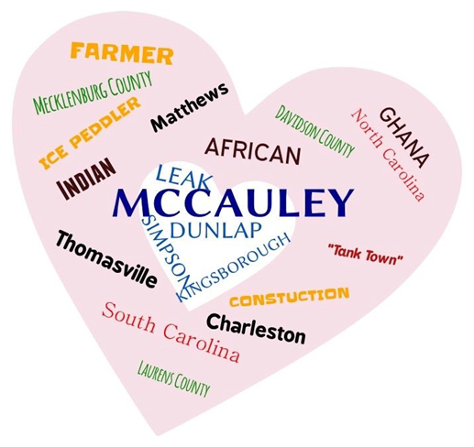

Robert Lee McCauley, Sr
Sarah Annie Dunlap
Lineage

Compiled by Iris McCauley Burke

Iris Burke

Contents
Preface 3
Robert Lee McCauley, Sr Family Tree 4
Fourth Generation 5
Third Generation 6
Fourth Generation 7
Third Generation 8
Sarah Ann Dunlap Family Tree 9
Grandmother 9
Fourth Generation 10
Third Generation 11
Fourth Generation 12
Third Generation 13
Second Generation (Grandparents) 14
Second Generation (Grandparents) 16
McCauley Family tree 17
Grandparents 18
Leroy Children 23
Edward Children 26
Marjorie Children 31
MacDowell Children 36
Annie Children 38
Robert Children 40
History/Facts 42
History/Facts 42
History/Facts 43
History/Facts 44
History/Facts 45

Preface

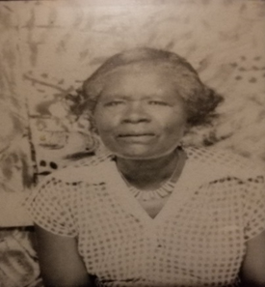
Eliza Kingsborough Dunlap
The Matriarch

This journey began as a simple hobby, but one day I had an epiphany: our roots deserved to be shared. What I have gathered here is truly made with love. Knowing where you come from makes you feel whole and reminds you that you are the product of two sets of DNAS. What I share here stands for one side of that story; I encourage you to explore the other as well.
My only regret is not speaking with my mother, Mildred Livingston, before she passed. She was a remarkable historian who remembered everything. Without her, this task has been laborious, costly, and at times incomplete—but I would not change a thing. It has been worth every effort to preserve what I could.
There are gaps, as Black history often leaves us, and sadly, I could not find a photograph of my grandparents, Robert and Sarah McCauley. Please remember that this record reflects my place on the family tree; your connection with these ancestors may differ.
It is my deepest wish that someone else will continue the search. As technology evolves, more discoveries will surely come to light. Share what you find with the family, so that together we may weave a fuller story of who we are.

I will start with my grandfather, Robert Lee McCauley, Sr. His parents, Grover and Annie, are my great-grandparents.

2nd Great Grandparents (McCauley)

Leroy McCauley
Birthdate/ place: April 1857/ Alabama
Occupation: Farmer
Misc.: met in South Carolina
Death & Place: Mecklenburg County
Burial: Unk

Althea Ross
Birthdate/ place: May 1861/ Virginia
Occupation: homemaker
Misc.: learned to read and write
Death & Place: unable to find.
Burial: ukn

Leroy and Althea were the roots of a sprawling family tree, their union blessed with ten children who carried their legacy into the world. Life in their household was never quiet; each child brought a unique spark, and together they created a lively chorus of voices, laughter, and occasional mischief. Among the ten was Grover, a boy with a curious mind and a steady heart.

Great Grandfather

Grover McCauley
Birthdate/ place: May 1888/ Thomasville, NC, Davidson County
Occupation: self-employed as an Ice Peddler
Education: sixth-grade education. He was able to read and write.
Death & Place: March 30, 1939. The cause was pneumonia secondary to the flu.
Burial: Roseville (Roseland) Cemetery, Matthews, NC (Now a historical site)

Grover’s Siblings:
Etta
Patrick H
Ida (Wake County)
Florence – married Crawford Burke (Matthews Murkland Presbyterian Church) 1/1/1855 -9/3*1955
(Grover)
Ollie (Olive) Patterson (Matthews Murkland PC)
Edward
Ruthes
Samuel
Geneva
Leola
Dexter (Pinewood)

2nd great-grandparents

Wash Leaks
Birthdate/ place:
Occupation:
Misc.:
Death & Place:

Eliza (Emma)
Birthdate/ place:
Occupation:
Misc.:
Death & Place:

This union produced 2 children. The parents of Annie.

great-grandmother

Annie Lee Leaks
Birthdate/ place: May 21, 1889
Occupation: Maid at a private home
Education: 7th-grade education, could read and write
Death & Place: October 17, 1947, Charlotte, NC
Burial: Roseville (Roseland), Matthews, NC

Sibling:
Will

Annie married Grover McCauley on March 28, 1909. They produced/ raised eleven children. Robert Lee McCauley, Sr, is one of the children.

Sarah Ann Dunlap Family Tree

Grandmother

2nd great- grandparent

Alfred Kingsborough
Birthdate/ place: August 1845/ Clinton, SC, Hunter Township
Occupation: Farmer
Misc.: Frank J. Kingsborough and Georgia Maria are the parents of Alfred Kingsborough (2nd Great Grandfather on Grandmother’s side).
Frank was born in 1814 in Clinton, SC, Hunter’s township in Laurens County. Unknown year of death. He was a farmer. He was able to read but did not master writing.
Georgia Maria was born in 1825 in the same area as her husband. She was a housekeeper and raised their children.
Death & Place: Laurens County, SC

Alice Simpson
Birthdate/ place: 1858/ Laurens, South Carolina
Occupation: Laborer
Misc.: William Simpson, Sr, born 1838, AKA Buck, was a farmer. He married Matilda. Matilda was born in Laurens, South Carolina. They were the parents of Alice Simpson.
Death & Place:

Alfred married Alice Simpson, and they are the parents of Eliza Kingsborough (Grandmother)

Great Grandmother

Eliza Kingsborough
Birthdate/ place: March 14, 1891/ Laurens County, SC.
Occupation: Laborer on a farm/ homemaker
Education: did not attend school. However, she was able to read and write.
Misc.: She was known as “Mama Liza.”
Death & Place: succumbed to arteriosclerotic cardiovascular disease (stroke), 11/09/1971.
Burial: York Memorial Park, Charlotte, NC

Sibling:
William
Emma
(Eliza)
George
Mary
Henry
Carrie

Fourth Generation

Milledge Dunlap
Birthdate/ place: 1861/ Cross Hill, Laurens, SC
Occupation: unknown
Misc.: Able to read and write
Sam Dunlap and Hannah Young are the parents of Milledge Dunlap.
Sam Dunlap was born in 1820 in Laurens County, SC. His trade was farming.
Hannah Young was born in 1843 in Richland, SC. Date of death is unknown; cause was acute nephritis.
Death & Place:

Caroline Miller
Birthdate/ place: 1867 Laurens County, SC
Occupation: Homemaker
Death & Place: SC

Milledge Dunlap and Caroline Miller are the parents of Lewis Robert Dunlap (great-grandfather).

Great-grandfather

Lewis Robert Dunlap
Birthdate/ place: March 10, 1888/ Laurens County, SC
Occupation: farmer/ laborer
Misc.: unable to read and write
Death & Place: February 10, 1967/ Community Hospital / Acute Myocardial Infarction (heart attack) because of colon cancer with metastasis
Lewis married Eliza Kingsborough.
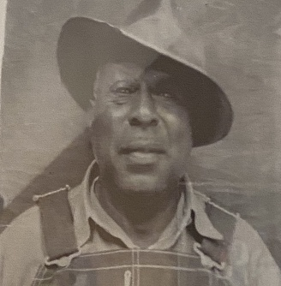

Lewis’s siblings:
Mary
Hattie
Lewis

Grandmother

Sarah Annie (?Lugener) Dunlap
Birthdate/ place: July 13, 1908/ Laurens County, Clinton, SC
Occupation: Home Keeper
Education: fourth grade/ able to read and write
Misc.: She was the second of 7 children. Aunt Margie remembers that all the kids were sick with cold-like symptoms. An MD came to the house to treat the children. They were all given an injection (PCN). Aunt Margie assumed PCN, and she was assumed to be allergic. She received the injection as well and at once had stroke-like symptoms. Never spoke since then and eventually passed away. (She was more likely allergic to PCN). Aunt Margie states that Ruth Dunlap (Fisher) was at her bedside during the entire time and took care of her until she passed. I never knew this until June 13, 2020.
Death & Place: April 22, 1953, at home. Funeral at Mt. Moriah Baptist Church, Matthews, NC. Reverend VC Robinson was the Pastor.
Burial: April 26, 1953; Roseville (Roseland) Cemetery, Matthews, NC
Siblings:
Robert Milledge
(Sarah Ann)
Alfred
George Henry
Caroline (Cleo, Julia) Aunt Sis
Antoine (Annie)
Mary (Aunt Mat)

Sarah’s Siblings Photos

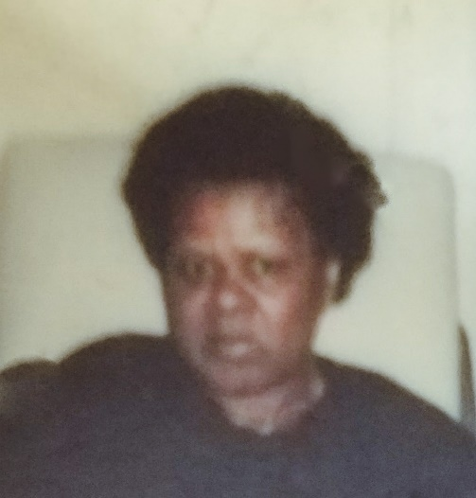
Caroline (Aunt Sis) Dunlap

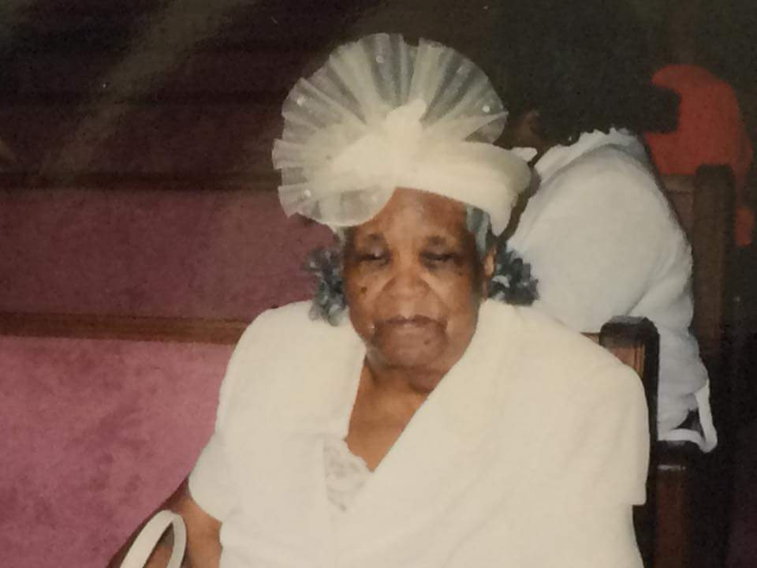Mary (Aunt Mat) Dunlap Burke Hagins
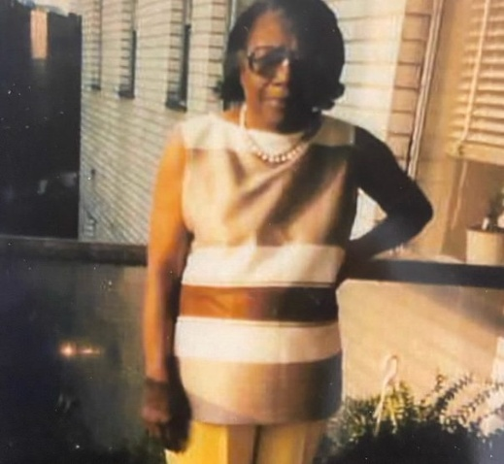
Antoine Dunlap (Annie)

Grandfather

Robert Lee McCauley, Sr
Birthdate/ place: September 29, 1909/ Thomasville, NC
Occupation: Farmer, Laborer, Construction Worker (Hope construction co.)
Education: third-grade education, could read and write
Misc.: Aunt Margie remembers that he passed out at work and passed away there from a heart attack. The going-away service was held at Mt Moriah Baptist Church. JC Robinson p the services.
Death / Place: July 27, 1959/ Charlotte, NC @ Good Samaritan Hospital; Buried at York Memorial

Siblings:
George Thompson
Josephine
Coretta
Catharine
(Robert Lee)
Inez
Curtis Vincent
Rudolph
Kenwood Rose
Wilburn Mary
Grace Elizabeth

Robert McCauley Siblings Photos
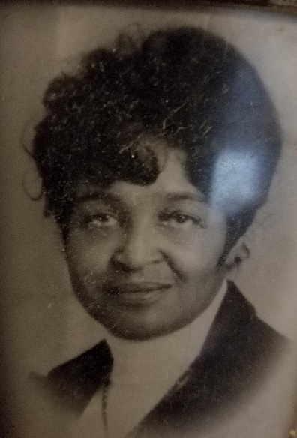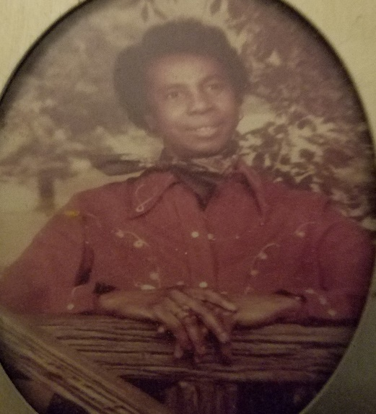
Grace Elizabeth McCauley Stevenson Wilburn Mary McCauley
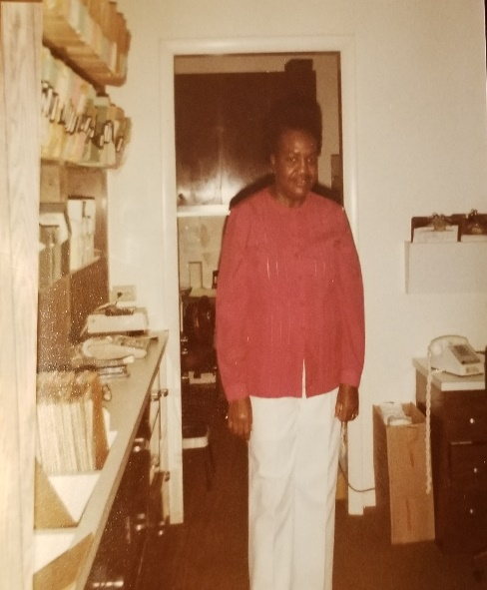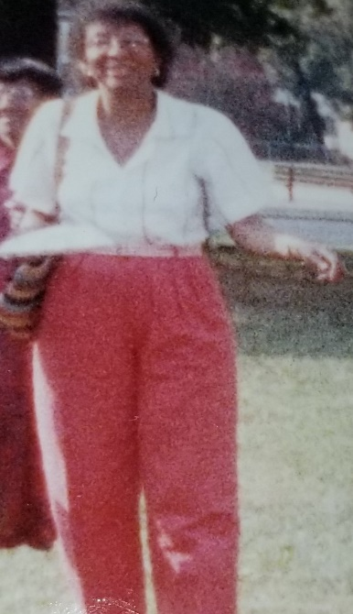
Kenwood Rose McCauley Jones Catharine McCauley Williams

McCauley Family Tree

Grandparents

Robert Lee McCauley, Sr, and Sarah Ann Dunlap McCauley

This union has the surnames of McCauley, Leaks, Kingsborough, and Simpson.

Robert and Sarah were married.

They met in North Carolina. They raised their family in Matthews, NC. (Stumptown). They owned property there as well.

The union produced 8 children; there were 10: (the first 2 names may not have been a product of the union):

McCauley Children:
Rose Downs (Davis) – Robert’s
George Dunlap (Lil George) – Sarah’s
Leroy
Edward “Eddie” Alfred
Marjorie
Mildred Inez
Rudolph “Ruddy”
MacDowell “Mac”
Annie Lee
Robert Lee, Jr. “Bro”

Rose Downs
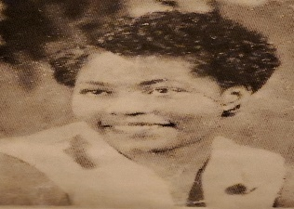
Birthdate/ place: September 27, 1928/ Matthews, NC
Mother: Bleeka Downs
Occupation: beautician, stewardess, Pan Am World Airlines, social worker in the NYC public school system
Education: High School in Mecklenburg County, Johnson C. Smith, Beauty School, Monroe Business School, bachelor’s degree from Lehman College of Business
Misc.: Volunteered at the Bronx Women against rape organization
Death & Place: February 9, 1993/ New York

George H. Dunlap
No photo available

Birthdate/ place: 1927 or 1926 (3 years old on the 1930 federal census)/ North Carolina
Education: Unknown
Misc.: I remember my mother, Mildred, telling me that he passed away after eating a green apple. Aunt Margie said he fell from a barn and never recovered.

Death & Place: Before 1940/ Matthews, NC

Leroy McCauley
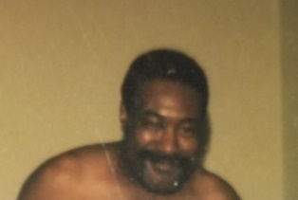
Birthdate/ place: September 27, 1937
Occupation: Train station
Education: Attended school in Mecklenburg County
Misc.: Married Barbara Ann Grier in 1968 in Manhattan, NY
Death & Place: date / New York

Children:
Leroy Henry Lawrence
Wyatt Alphonso Lawrence
Linda Wright Goode
Patricia McCauley
Pamela Renee McCauley
It is believed he also has 3 sons in New York.

Leroy Children

Leroy Henry Lawrence
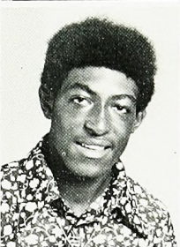

Children Biography:
Birthdate/ Place: November 21, 1956, Charlotte, NC
Education: East Mecklenburg High School
Mother: Willie Lawrence of Matthews, NC
Nickname: Skipper, Skip
Death: May 25, 1980, Charlotte

Wyatt Alphonso Lawrence
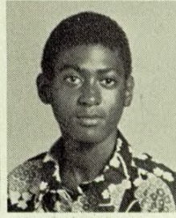

Children Biography:
Birthdate/ Place: August 28, 1959, Charlotte, NC
Education: East Mecklenburg High School
Occupation: Vision Cable, Cable technician
Nickname: Fonzo, Fonz
Mother: Willie Lawrence of Matthews, NC
Children: Tiffany
Death: Jan 31, 1998, at home
Linda Wright Goode
No Photo

Children Biography:
Birthdate/ Place: NC
Education:
Occupation:
Married:
Children:
Mother: Betty Mae Wright

Patricia McCauley

Children Biography:
Birthdate/ Place: March 20, 1968, New York
Education: High School, Military
Occupation: Military
Mother: Barbara Ann Grier

Pamela Renee McCauley
No Photo
Children Biography:
Birthdate/ Place: August 1, 1964
Education: high school
Occupation:
Married:
Mother: Barbara Anne Grier

Edward Alfred McCauley
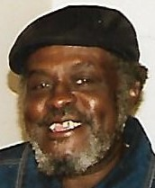
Birthdate/ place: September 23, 1938/ Mecklenburg County, NC
Occupation: Mechanic
Education: Attended HS in Mecklenburg County
Misc.: Married Arnetha Cureton January 19, 1959. The union produced 7 children. They divorced on December 8, 1986.
Death & Place: Still Living
Children:
Rickey Cureton
David Cureton
Charles
Sarah Deloris
Wayne
Robin
Lorenzo
Nicole Bennet – Mother Pearl Bennet

Edward Children

Rickey Cureton
No Photo
Children Biography:
Birthdate/ Place:
Education:
Occupation:
Married:
Children:

David Cureton
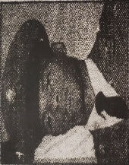
Children Biography:
Birthdate/ Place: June 8, 1954, Charlotte, NC
Education: Charlotte-Mecklenburg School System
Occupation: Crew Chief, Sunlight International Roofing Co
Misc. Served in the military
Children: Damion Owens, Nicole McCree
Death: June 22, 1991, Accident

Charles McCauley
No Photo
Children Biography:
Birthdate/ Place: May 18, 1956, Charlotte, NC
Education: Charlotte-Mecklenburg School System
Occupation:
Children:
Death: November 19, 2007, Charlotte, NC

Sarah Deloris McCauley
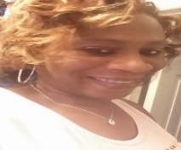
Children Biography:
Birthdate/ Place: November 30, 1959, Charlotte, NC
Education: South Mecklenburg HS
Occupation:
Married:
Children:

Wayne McCauley
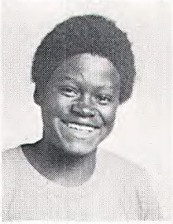
Children Biography:
Birthdate/ Place: October 4, 1960, Charlotte, NC
Education: South Mecklenburg HS
Occupation:
Married:
Children:

Robin McCauley
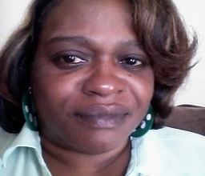
Children Biography:
Birthdate/ Place: May 12, 1962, Charlotte, NC
Education: South Mecklenburg HS
Occupation:
Married:
Children: Decarlio Lovell, Marqus Anthony

Alfred Lorenzo McCauley
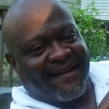
Children Biography:
Birthdate/ Place: September 8, 1966
Education: South Mecklenburg HS
Occupation:
Married:
Children: Sequoya
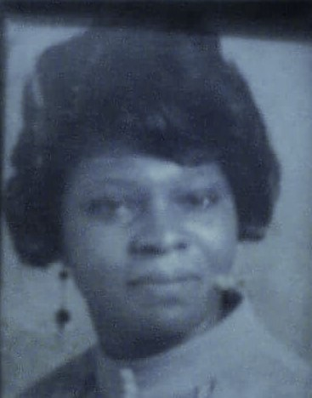Arnetha McCauley

Nicole Bennet
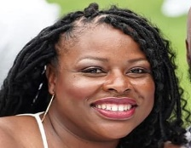
Children Biography:
Birthdate/ Place:
Education: Pfeiffer University
Occupation: Sheriff
Married: Carlo
Children: son
Mother: Pearl Bennet

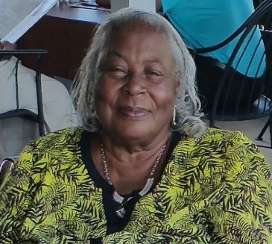Pearl Bennet
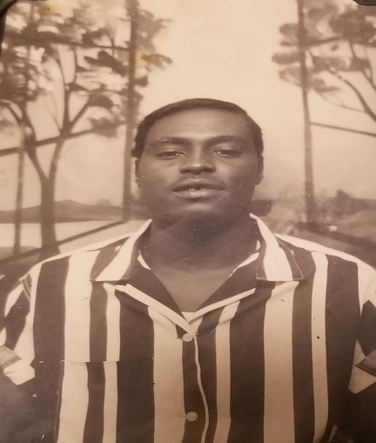
Margorie McCauley Rich
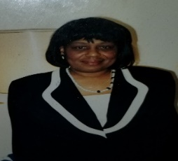

Birthdate/ place: May 27, 1939/ Mecklenburg County
Occupation: Licensed Practical Nurse/ Business owner (Quality Plus)
Education: JH Gunn High School graduate/ Central Piedmont Community College
Misc.: She married Johnny Rich; they later divorced.
Death & Place: July 12, 2025, at home
Burial: York Memorial Park
Children:
Milton Avery
Gerald Kent
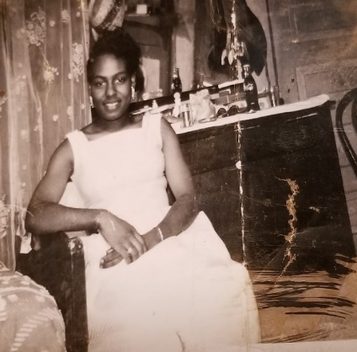
Marjorie Children

Milton Avery Rich
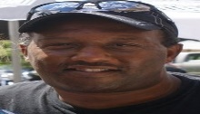
Children Biography:
Birthdate/ Place: January 15, 1961
Education: Olympic HS; Central Piedmont
Occupation: Salesman

Gerald Kent Rich
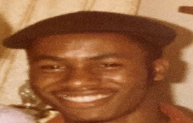
Children Biography:
Birthdate/ Place: January 22, 1963
Education: Olympic HS; Attended UNCG
Death: Automobile Accident Passenger; November 13, 1984
Burial: York Memorial Park, Charlotte, NC

Mildred Inez McCauley Livingston
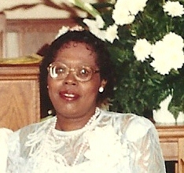
Birthdate/ place: August 16, 1940
Occupation: Newco Fiber, Driftwood Restaurant
Education: JH Gunn High School
Misc.: Mildred’s blindness was diagnosed when she was very young. She underwent a corneal transplant procedure to correct her vision. I remember her MD as Dr. Tilley, whose office was on Monroe Rd. She wore glasses for the rest of her life. She married Richard Bob Livingston.
Death & Place: December 12, 2012, at Hospice, Presbyterian Hospital (Novant)/Charlotte, NC
Burial: York Memorial Park. Chappel Memorial Baptist Church hosted the farewell service.
Children:
Iris Ramona (Kerwin)
Beverly Quinn (Gregory)
Latisha Jenean Livingston (Ollie)

Mildred Children
Iris McCauley Burke
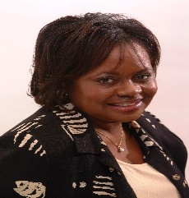
Children Biography:
Birthdate/ Place: March 29, 1960
Education: East Meck HS, BSN, NC A&T State University, MHA, UNCC
Occupation: Nursing
Married: Kerwin Burke
Child: Jamilla Aisha

Beverly McCauley Camp
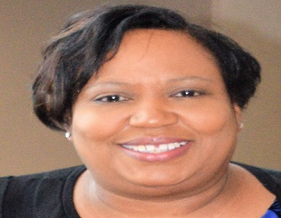
Children Biography:
Birthdate/ Place: May 11, 1963
Education: Harding HS, Attended North Carolina A&TSU, UNCC BS African American Studies
Occupation: Dean of Culture, Education
Married: Gregory Dexter Camp
Children: Sherrod (Tiffany), Jarett (Dorian), Brittany, Brian
Grandchild - Maddison

Mildred Children

Latisha Livingston Meeks
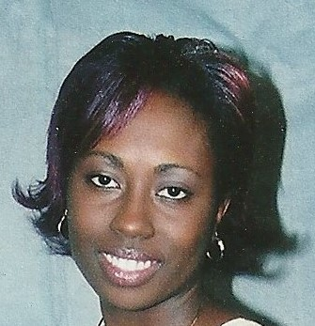
Children Biography:
Birthdate/ Place: October 18, 1975
Education: West Mecklenburg HS, Attended NCA&TSU, Dudley Beauty School
Occupation: Hair Stylist, Office Manager
Married: Ollie Meeks Jr
Children: Moriah Banks (Marcus), Briana Livingston (Zantarious), Ollie Meeks III (Alex)
Grandchildren – Jariah, Yasir, Brylie, Millie Jade

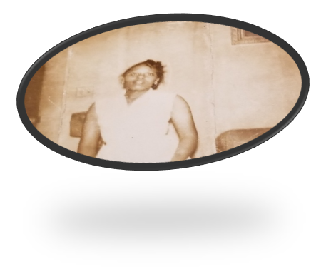
Rudolph McCauley
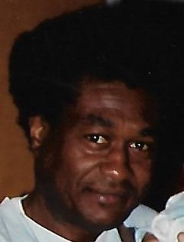
Birthdate/ place: May 13, 1943/ Mecklenburg County
Occupation: City of Charlotte
Education: Attended Matthews Elementary
Misc.: Soft spoken and kind. He was known as Rudy.
He moved in with Marjorie, his oldest sister, until his death.
Death & Place: July 21, 2004/ at his home
Children: Baby girl preceded her father in death

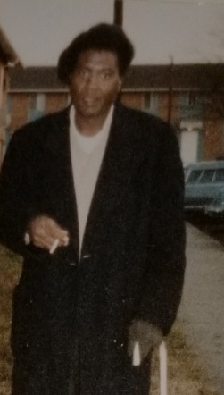
MacDowell McCauley
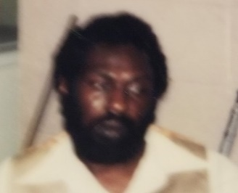
Birthdate/ place: June 18, 1945/ Mecklenburg County
Occupation: Security Guard
Education: Charlotte-Mecklenburg School System
Misc.: He lived in Georgia after leaving his home in Matthews/Charlotte for most of his adult life. Never married
Death & Place: April 10, 1996/ Atlanta, Ga. He is laid to rest in Charlotte, York Memorial.
Children:
Sherry Elaine Bryant
Sherese Denise Bryant
Mother: Ella Mae Duboise
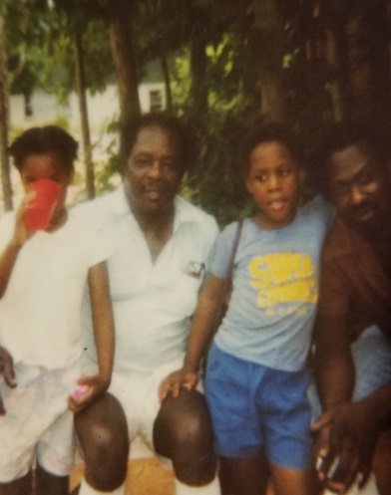

MacDowell Children

Sherry Elaine Bryant


Children Biography:
Birthdate/ Place: September 27, 1980, Atlanta, Ga
Education: Carver High School
Occupation: Self-Employed
Children:

Sherese Diane Bryant
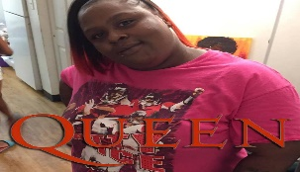
Children Biography:
Birthdate/ Place: September 27, 1980, Atlanta, Ga
Education: Carver High School
Occupation:
Children:
Death/ place: March 14, 2020, Atlanta, Ga

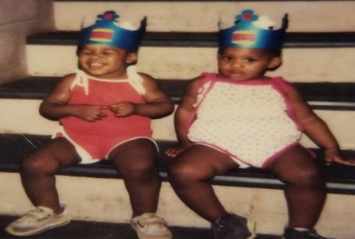

Annie Lee McCauley Faulkner
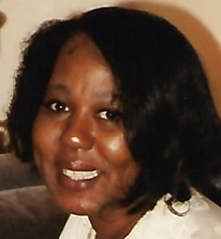
Birthdate/ place: February 24, 1947/ Mecklenburg County
Occupation: Hostess, Office Manager (Ophthalmology office)
Education: West Charlotte HS, Attended Fayetteville State University
Misc.: She was 6 years old when her mom passed. She was taken in by her Aunt Rose (father’s side) in Charlotte. She married Joseph Faulkner. Breast cancer survivor.
Children:
Lisa Rose McCauley
Jason Warren Faulkner (Tomekia)
Santora Ja’nea, Ja’Shaunti Quyon (Jakira), Jaylan (Warren), Jayson Kent
Jashawn
Javion
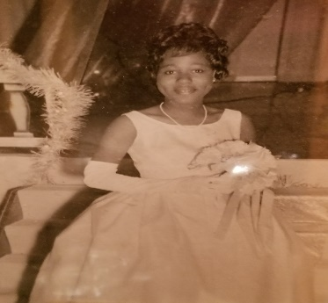

Annie Children

Lisa Rose McCauley
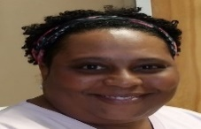
Children Biography:
Birthdate/ Place: July 4, 1969, Charlotte
Education: South Meck HS; Central Piedmont Community College, Wingate – sports medicine
Occupation: Physical Therapy

Jason Warren Faulkner
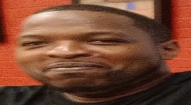
Children Biography:
Birthdate/ Place: October 9, 1974
Education: South Mecklenburg HS
Occupation: Laborer
Married: Tomekia Johnson
Children: Santoria, Jashaunti, Jayson, Jaylen, Ja’vione, Ja’shaun

Robert Lee McCauley, Jr
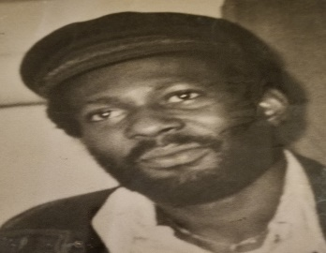
Birthdate/ place: July 2, 1952/ Mecklenburg County
Occupation: Club owner/ Bouncer
Education: Attended West Charlotte & Second Ward HS
Misc.: He was known as “Bro”. He married Andreina Beatty
Death & Place: July 4, 1980/ Charlotte, NC. Gunshot Wound

Children:
Phaleshia Yvette McCauley
Anthony Beatty (Stepson)
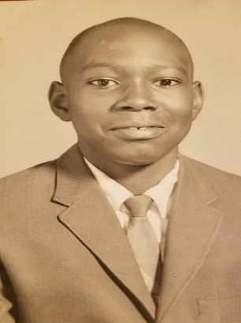

Robert Children

Phaleshia Yvette McCauley
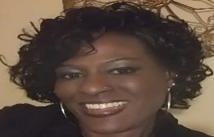

Children Biography:
Birthdate/ Place: October 22, 1969, Charlotte, NC
Education: West Mecklenburg HS, attended Central Piedmont Community College
Occupation: Disabled
Children: Antonia Marcus

Anthony Beatty
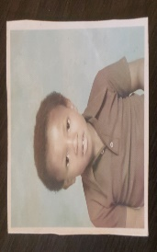

Children Biography:
Birthdate/ Place: Charlotte, NC
Education: Charlotte-Mecklenburg Schools
Death: unknown date

Historical Facts
Relevant to our history

History/Facts

Historical Facts Relevant to our history
Ghana is a country where we have roots, ancestors were born. Of course, it is in West Africa. Land mass is desert, savanna, and forest. National animal symbols – Tawny eagle and lion.

The Ghana Flag


Red- bloodshed to obtain independence.
Gold – Ghana’s industrial minerals wealth. One of the national symbols is the 5-pointed black star rimmed with gold, standing for the mineral gold wealth.
Green- rich tropical rainforest and natural resources

Lauren County, SC, was created in March 1785. First inhabited by the Cherokee Indians and by immigrants from Scotland and Ireland. Known for cotton. We have roots in Ghana. This is the area for the Dunlap side of the family.

Davidson County, NC – This is where our grandfather was born. The McCauleys. Specifically, Thomasville. This county was formed in 1822 from Rowan County.
Thomasville was incorporated on January 8, 1857. This town is known for furniture. It is also known to have the oldest railroad depot. The other claim to fame is Chair Town. Who remembers the enormous rocking chair?

History/Facts

Tank Town (Matthews)

Tank Town, later renamed Crestdale, is one of the most significant African American communities in North Carolina — and one of the oldest continuously inhabited Black settlements in the entire state. In 1963, the name was officially changed from Tank Town to Crestdale, reflecting a new era while still honoring the community’s deep roots.
Following the Civil War (1860s), newly freed African Americans set up a settlement just outside what is now Matthews, NC. These families-built homes, churches, and community life on their own land, creating a safe and self-sustaining place during Reconstruction and the decades that followed.
The name Tank Town came from a large water tank built in the late 1880s by the Carolina Central Railway. The tank supplied water to the steam trains that passed through the area.
Homes in the community were built near the tracks, including the home owned by your grandparents, Robert and Sarah McCauley, making your family part of this historic legacy.
The surrounding region was known for Cotton farming, which shaped much of the post‑Civil War economy. Timber, which provided work and supported the local industry. These trades helped sustain the families who lived in Tank Town for generations.

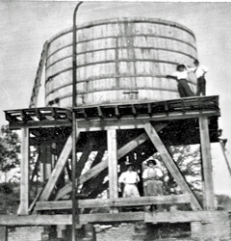

History/Facts

Tank Town (Matthews)

Tank Town is recognized as the oldest African American community in North Carolina. A Landmark African American Community. Its endurance through Reconstruction, Jim Crow, segregation, and modernization speaks to the strength and resilience of the families who built it.

The nearby town of Matthews was once known as Stumptown, named for the tree stumps left behind after extensive timber clearing.

In 1988, Matthews formally annexed Crestdale, bringing the historic community into the town’s municipal boundaries.

Mount Moriah Missionary Baptist Church

Founded in 1879. This church became a family church. A large number of our family members grew up within these walls. Our great‑grandmother and grandmother were faithful members. Some of our parents worshiped, served, and raised their children there. Countless family funerals were held in this sanctuary, marking it as a place where we celebrated life, mourned loss, and leaned on one another. This church is also part of my own life story — I was married there, adding another layer of meaning to a place already rich with family history.
For much of our lives, the church was shepherded by Pastor J.C. Robinson, whose long tenure shaped the spiritual direction and stability of the congregation. His leadership is part of the legacy we remember and honor.
While I was researching our ancestral lineage, there were mentions of some of our ancestors being buried in the Mount Moriah Baptist Church Cemetery. The Church records are difficult to obtain at this time.

Pastor JC Robinson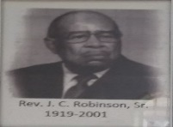

Mount Moriah Missionary Baptist Church

. This is a photo of the 1st building

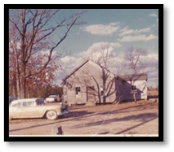

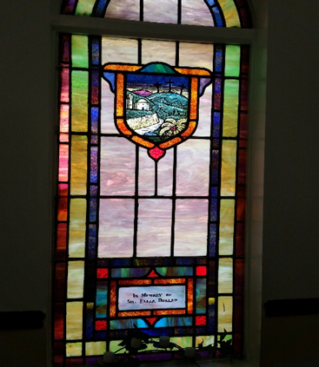

Eliiza Kingsborough Dunlap-Stained Glass Window from Mt. Moriah Baptist Church, Matthews, NC

Matthew Colored School- Crestdale

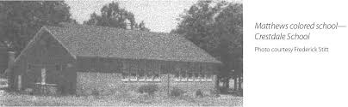

The school opened in 1918 as part of the Rosenwald Foundation initiative — a groundbreaking partnership between educator Booker T. Washington and philanthropist Julius Rosenwald. Their mission was to fund and build schools for African American children across the rural South during segregation, when public funding for Black education was severely limited.
This particular school followed the classic Rosenwald design, often called a “shotgun schoolhouse” — a long, narrow structure with classrooms arranged in a straight line.
These buildings were simple but sturdy.
They were filled with light, built with community labor, and became centers of learning, pride, and progress for Black families.
The school closed in 1966 as part of the broader push toward desegregation.
Nearly a decade later, in 1975, the building was destroyed in a fire, marking the end of its physical presence but not its legacy.

History/ facts

JH Gunn School

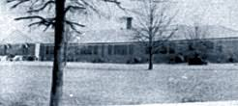

J.H. Gunn School holds a meaningful place in our family history and in the history of African American education in Mecklenburg County. The school served Black children and adolescents in eastern Mecklenburg County, and historical accounts note that it housed students from the first grade through graduation. Before it carried the Gunn name, it was connected with Clear Creek and was known as Clear Creek High School or Clear Creek Colored Union High School. James Henry “Jimmie” Gunn, for whom the school was later named, was more than an educator. He was an African American pianist, bandleader, and touring musician whose orchestra performed widely during the 1930s. His group, Jimmie Gunn and His Orchestra, recorded in Charlotte in 1936, placing him among the important Black musicians associated with the region’s jazz and territory-band tradition.
Like many Black musicians of his era, Gunn’s musical success did not guarantee a steady income. Around 1940, he turned toward education, teaching music and mathematics. By 1944, he had become principal of Clear Creek High School in Mecklenburg County. Historical sources show that the school was later named for him, with references placing the renaming in the late 1940s or, in some accounts, 1954. Although the exact date may vary by source, the connection is clear: the school’s name honors a man whose work joined music, education, and community leadership.
For our family, J.H. Gunn was not simply a public institution; it was part of our lived experience. My mother, Mildred, and Aunt Margie both graduated from this school, connecting our family directly to its high school years. Later, Beverly worked there for many years. Her younger children, along with my daughter, also attended when it served as an elementary school. In that way, J.H. Gunn became more than a school building. It became a place where several generations of our family learned, worked, and remained connected to the larger Black educational legacy of Mecklenburg County.
Research note: Public historical sources confirm Gunn’s dual legacy as a jazz musician and educator, his shift into teaching around 1940, his principalship at Clear Creek High School beginning around 1944, and the school’s later identity as J.H. Gunn School. The exact year of the formal renaming appears differently across sources, so more school-board records, yearbooks, alumni materials, or Charlotte-Mecklenburg Schools archives may help confirm the precise date.

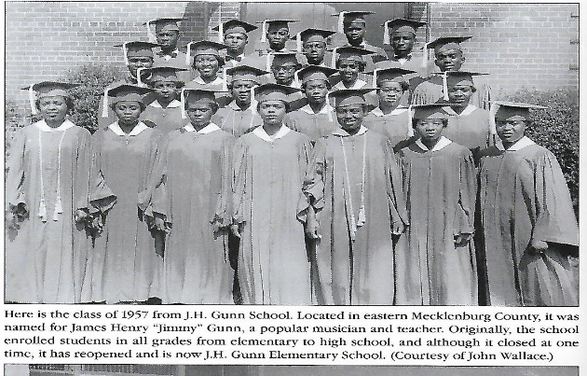 Class of ‘1957

History/Facts

Good Samaritan Hospital

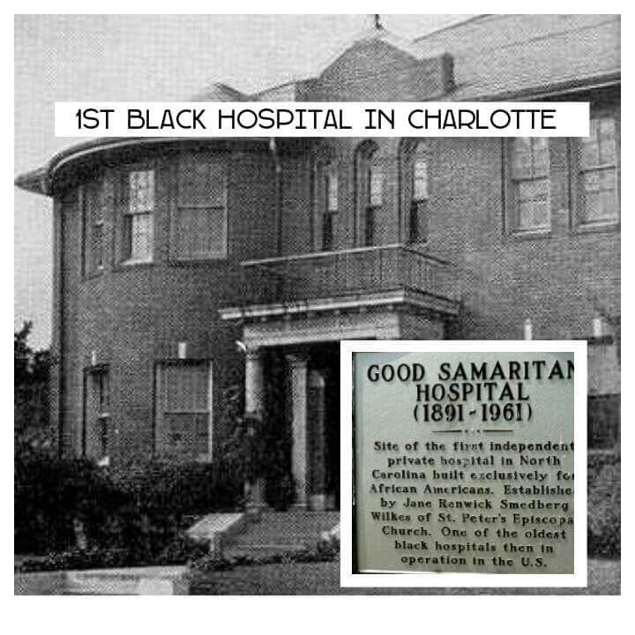

This hospital is recognized as the first Black-only private hospital in the United States, a groundbreaking institution created when African Americans were denied access to most medical facilities.
Ironically — and remarkably — the hospital was spearheaded by a white woman, Jane Renwick Smedburg Wilkes, a trained nurse and a member of St. Peter’s Episcopal Church in Charlotte.
She, along with other women from the church, raised funds and organized the effort.
Their work created a dedicated medical space for African Americans who had few, if any, options for care in the segregated South.
In 1903, the hospital expanded its mission by opening a nursing school for African American women.
This school became a vital pathway for Black nurses to receive professional training at a time when most institutions excluded them.
Your family’s connection is especially meaningful: Aunt Rose McCauley Jones, the sister of your Granddad Robert McCauley, attended this program. Her training placed her among the early generations of professionally educated Black nurses in the South.
The nursing school closed in 1959, after more than half a century of educating African American nurses.
Shortly afterward, in 1960–1961, Charlotte Memorial Hospital (now Atrium Health Carolinas Medical Center) took ownership of the hospital. This transition marked the end of its independent operation, but not the end of its legacy. Iris McCauley was born in 1960 at Charlotte Memorial Hospital, which is also historic, along with some of our other relatives.

Roseland (Roseville) Cemetery

Roseland Cemetery, also known in some records and family references as Roseville Cemetery, is a sacred resting place for generations of African American families connected to Matthews and the surrounding communities. Many of the people buried there were foundational members of nearby neighborhoods, including Tank Town/Crestdale, and were also connected to the local church community. The cemetery carries cultural, genealogical, and spiritual significance because it preserves the names and resting places of people whose lives helped shape the Black community in this area.
In 2021, Roseland/Roseville Cemetery was officially selected for historic recognition, acknowledging its importance as a site of African American history, family memory, and community heritage. The cemetery is found behind the apartment complex near 10288 Monroe Road and 9100 New Towne Drive, making it somewhat hidden from the main road but deeply important to the families whose ancestors rest there.

Known family members buried at Roseland/Roseville Cemetery, based on death certificates and family research:
Annie Lee Leaks McCauley — mother of Robert Lee McCauley, Sr.
Grover McCauley — father of Robert Lee McCauley, Sr.
Sarah Annie Dunlap McCauley — wife of Robert Lee McCauley, Sr.

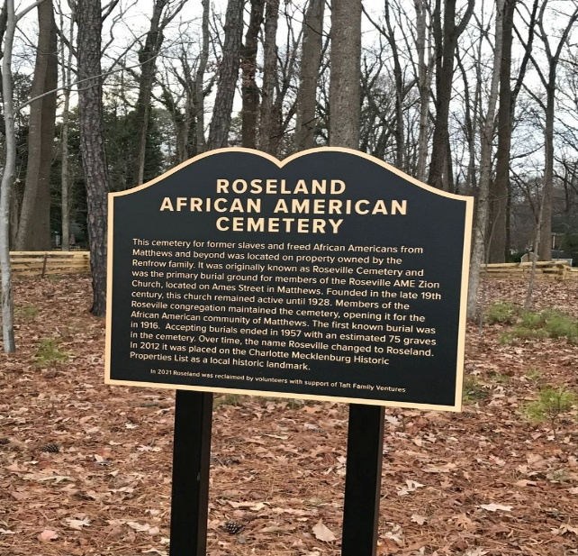

York Memorial Park
5150 S. Tryon St, Charlotte

York Memorial Park is where the majority of our ancestors are laid to rest. It is a historically significant Black cemetery serving as the final resting place for generations of African American families, civil rights leaders, and veterans. The cemetery also holds graves that were moved from other African American cemeteries in the area after those burial grounds were displaced by urban development.
I will not list the individual family members resting here; know that there are a large number, and their presence makes this cemetery one of the most important ancestral sites in our family history.

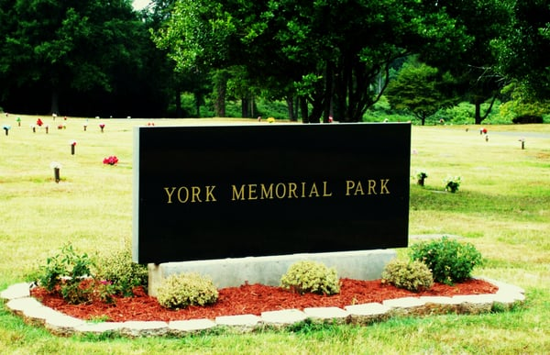

Second Ward (Charlotte Colored High School)

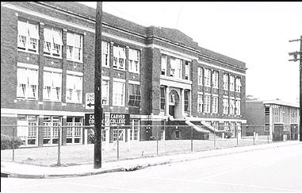

Established in 1932, this school holds a distinguished place in Charlotte’s history and our legacy as the first public school built specifically for African American students. At a time when educational opportunities for Black children were severely limited, this school became a beacon of learning, pride, and community advancement.
The school served students in grades 7 through 12, providing both middle‑ and high‑school education under one roof.
From its opening in 1932 until West Charlotte High School was built in 1938, this school was the only high school available to African American students in the entire city.
Members of your own family attended and graduated from this school, making its story part of your family’s educational heritage through the 21st century. Their achievements reflect the strength of the school’s academic and cultural foundation.
In 1969, the school was closed as part of Charlotte’s integration efforts.
The school is known for having a powerful, active, and deeply connected alumni community. Graduates continue to honor the school’s legacy through reunions, preservation efforts, and community engagement.
The school’s gymnasium has been recognized as a historic landmark, preserving a physical piece of the school’s legacy.

